## PROJECT TITLE : JOB TRACKING SYSTEM

# 1.Introduction

1.1.Overview

# Job application system helps the applicant to track the number of jobs he applied and helps him find the job posted by various recruiters.

1.2.Purpose

### It helps to easily identify jobs in companies or offices.Many job seekers will benefit from this.

# 2.Problem Definition & Design Thinking

2.1.Emphathy Map

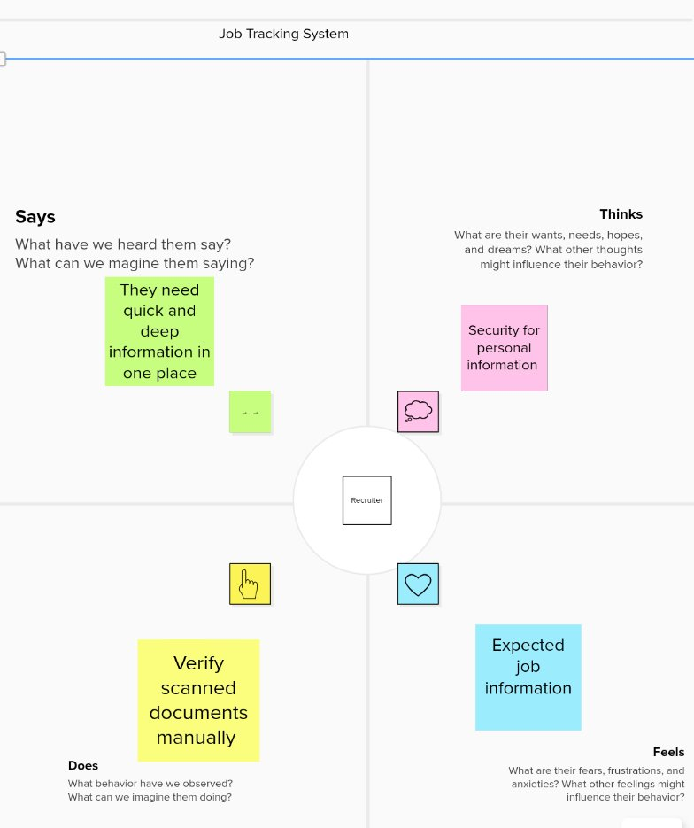

2.2.Ideation & Brainstroming Map



3.Result

3.1.Data Model:

|  |  |  |  |  |  |  |  |
| --- | --- | --- | --- | --- | --- | --- | --- |
| Object Name  Obj1 Recruiter | Fields in the object     |  |  | | --- | --- | | Field Label | Data Type | | Recruiter | Lookup(User) | | Recruiter | Lookup(User) | |
| Obj2 Description | |  |  | | --- | --- | | Field Label | Data Type | | Description | Lookup(User) | | Description | Lookup(User) | |

3.2.Activity & Screenshot

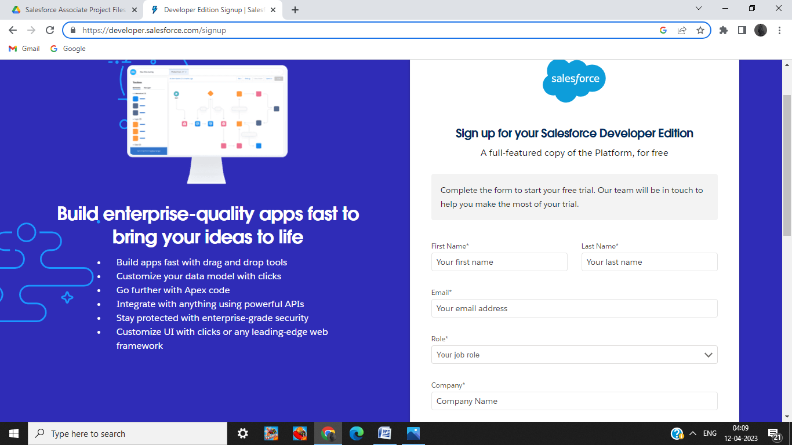

Salesforce login

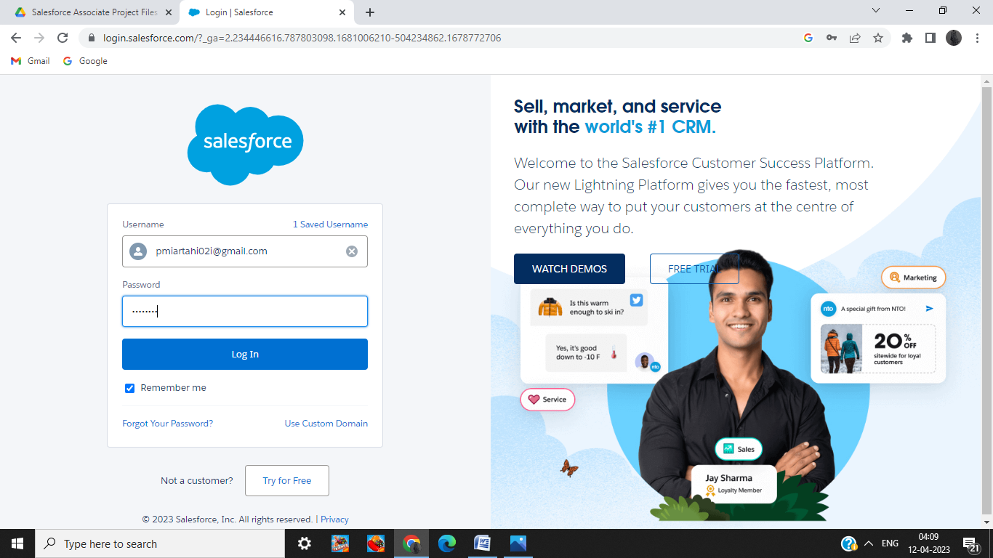

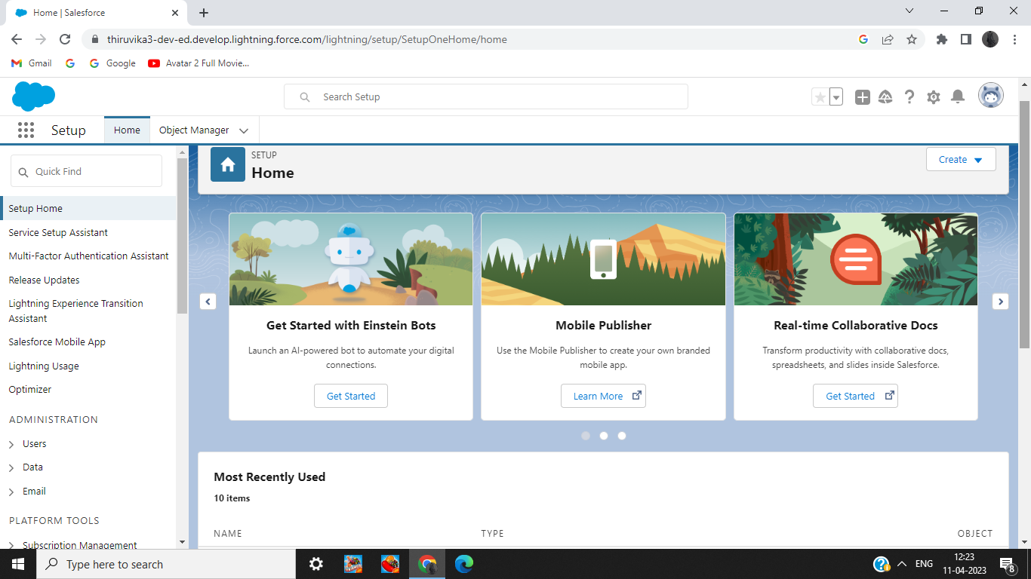

Custom object for Recruiter

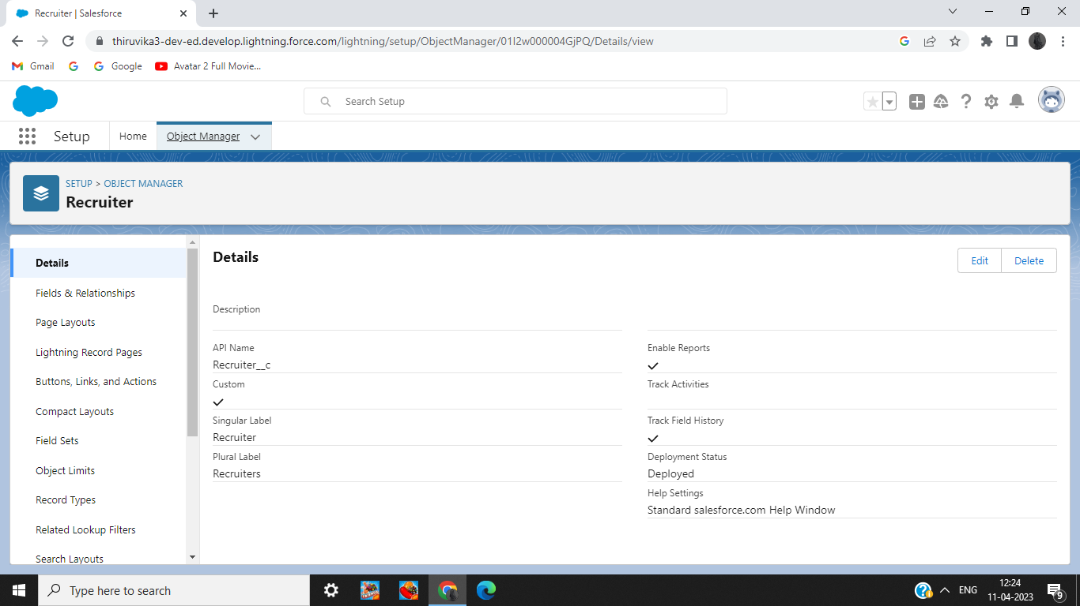

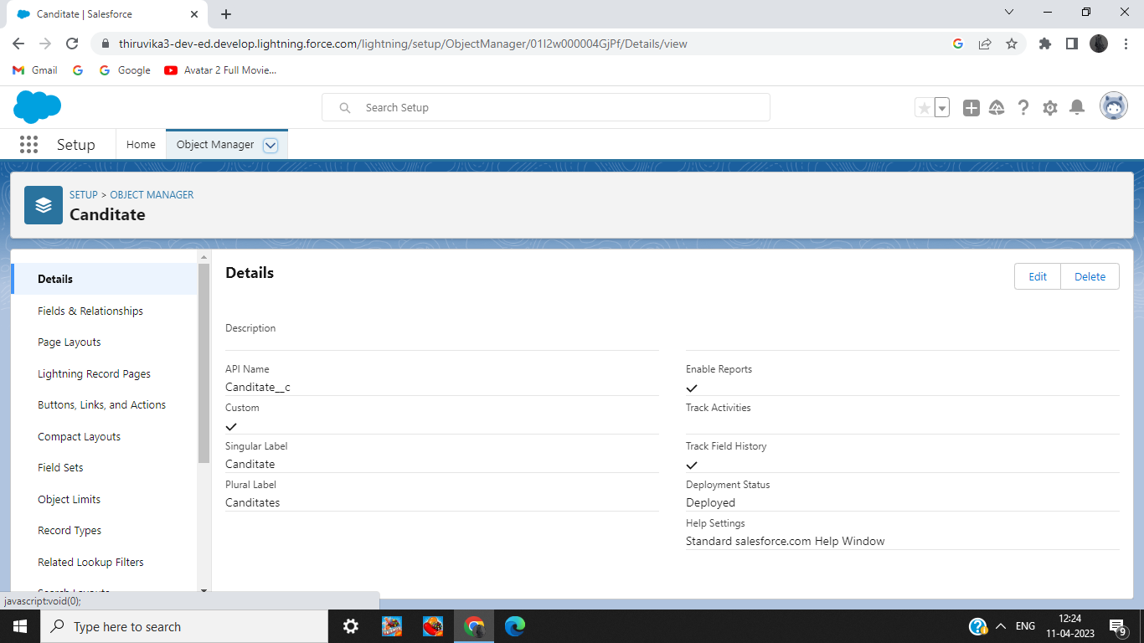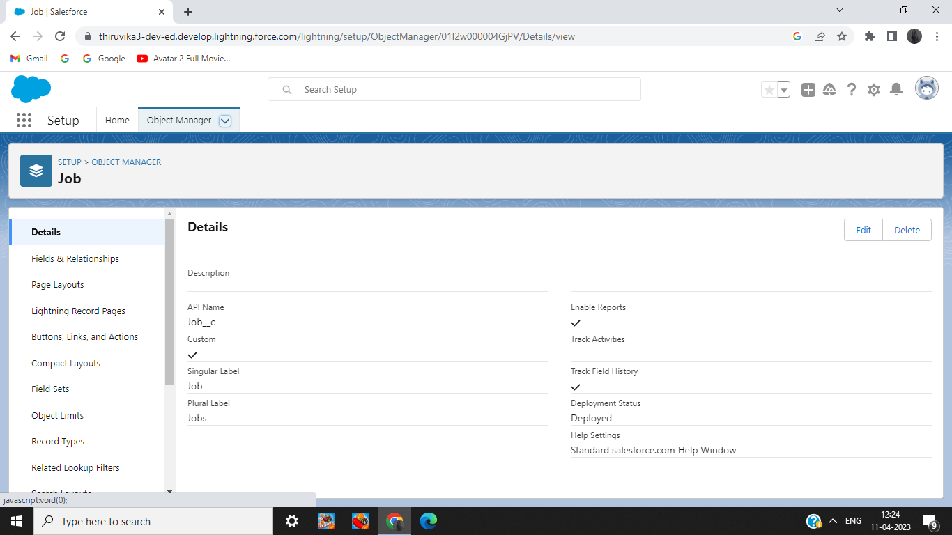

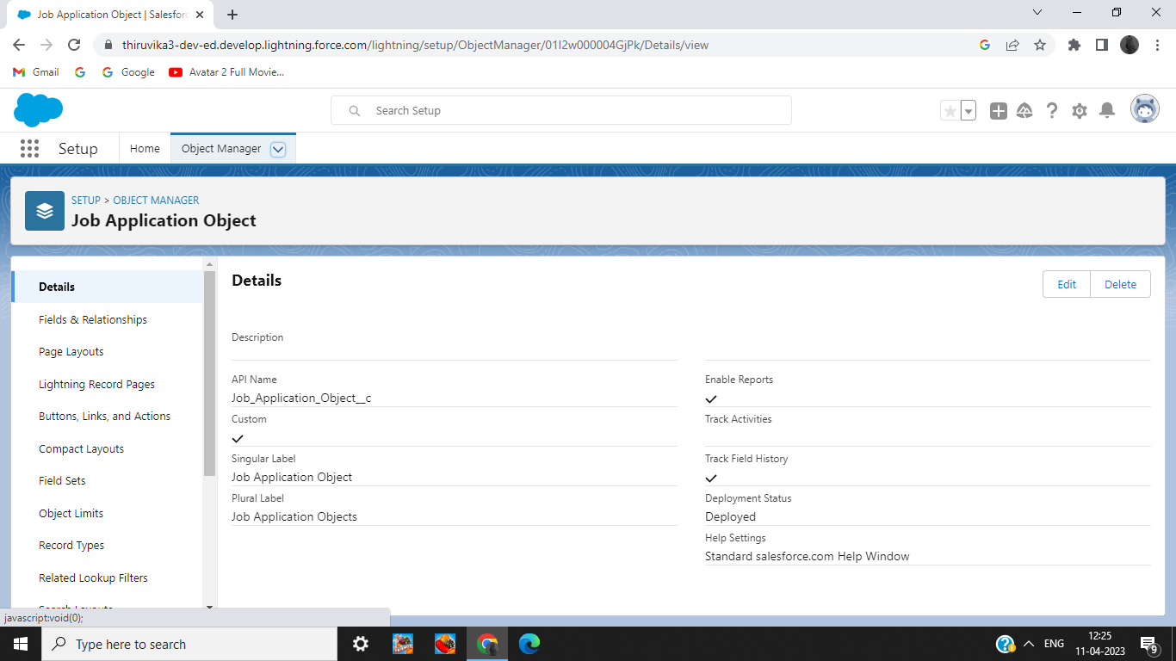

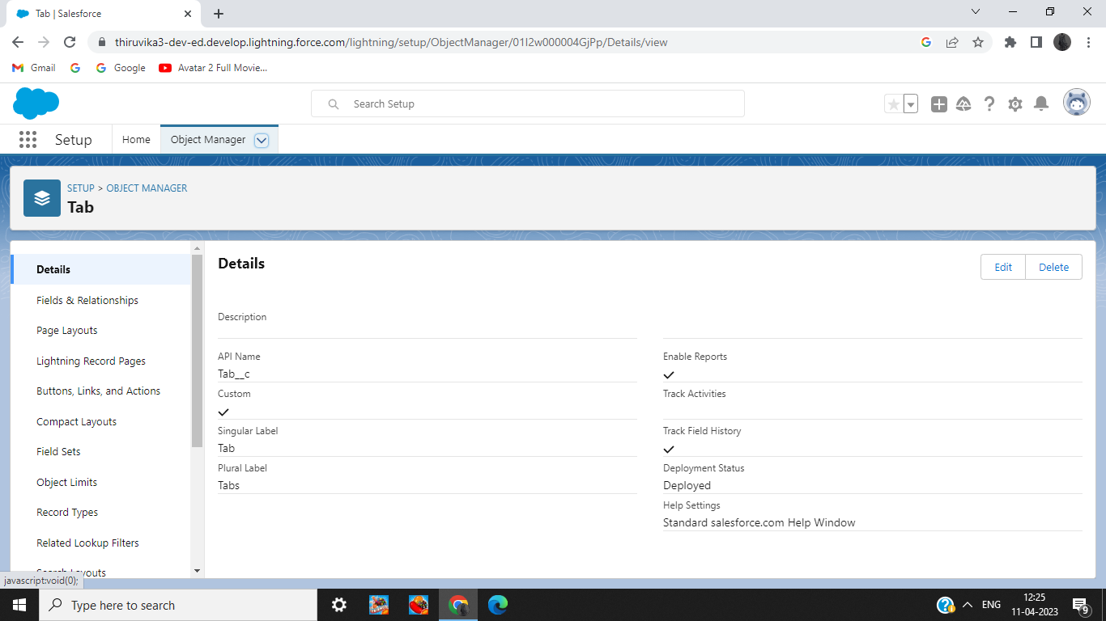

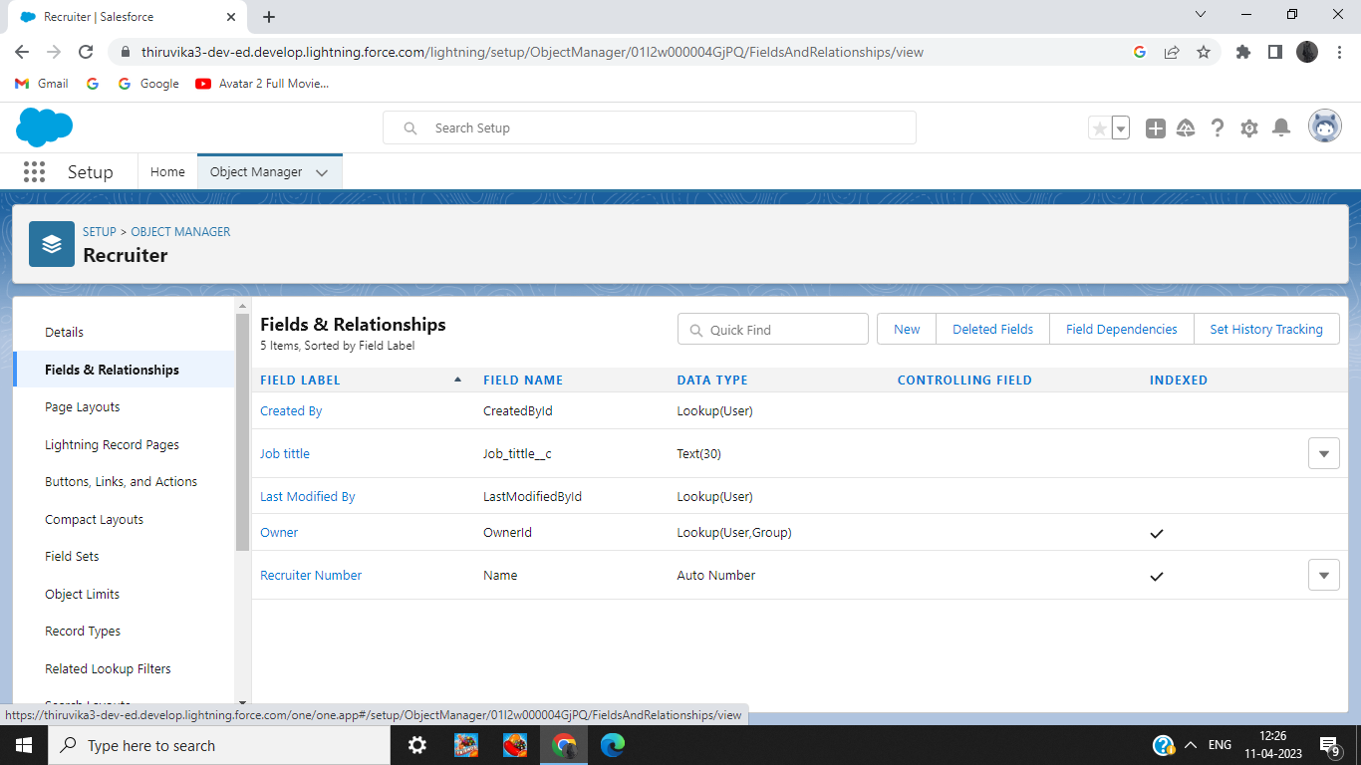

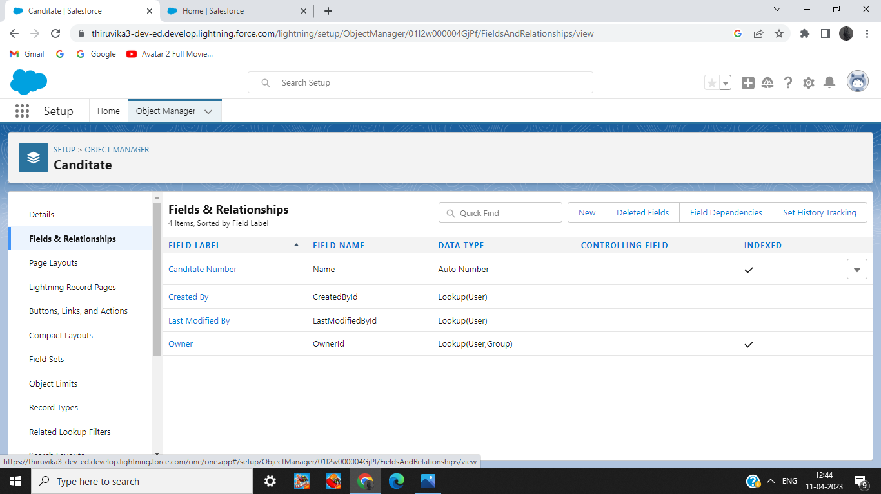

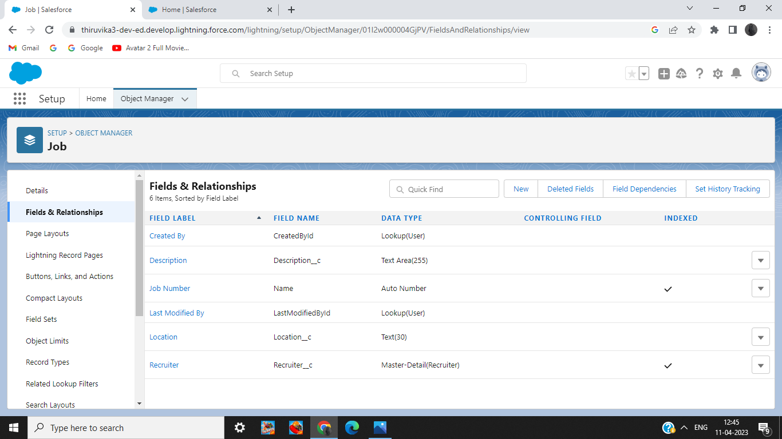

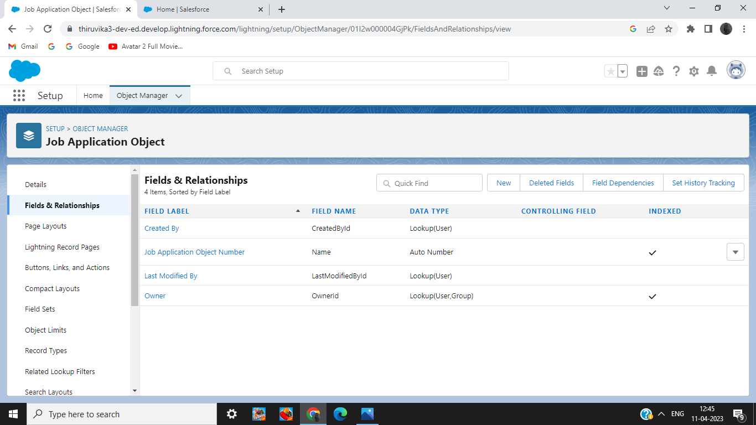

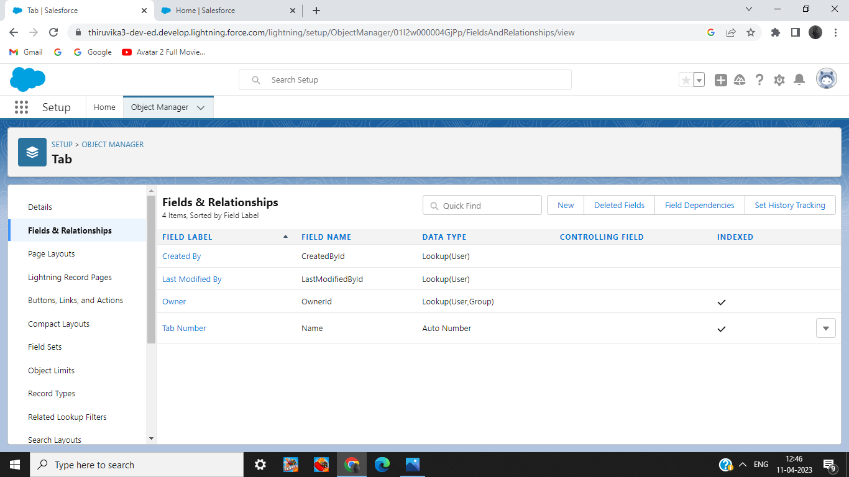

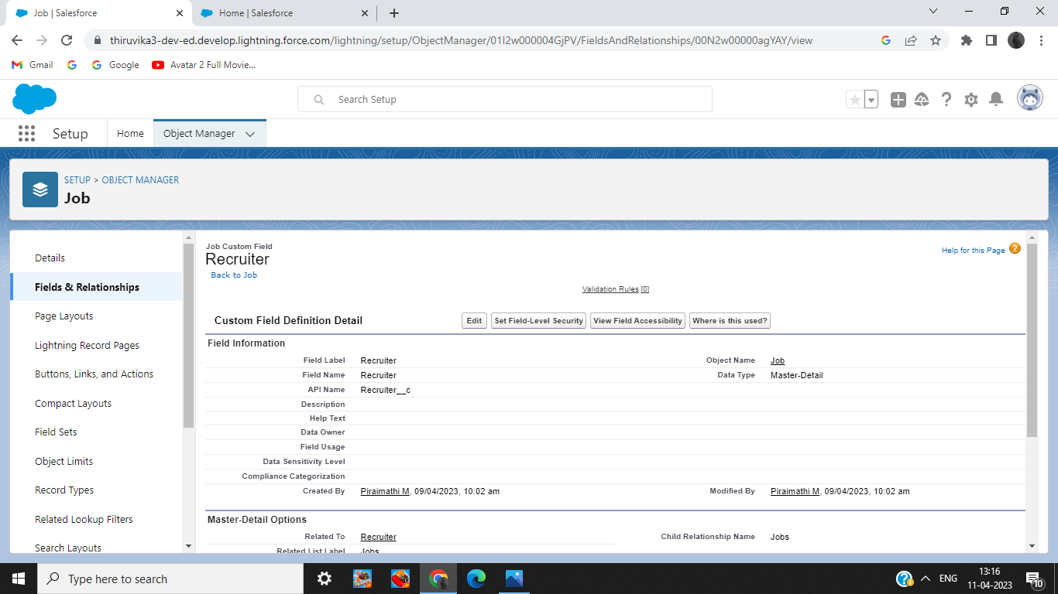

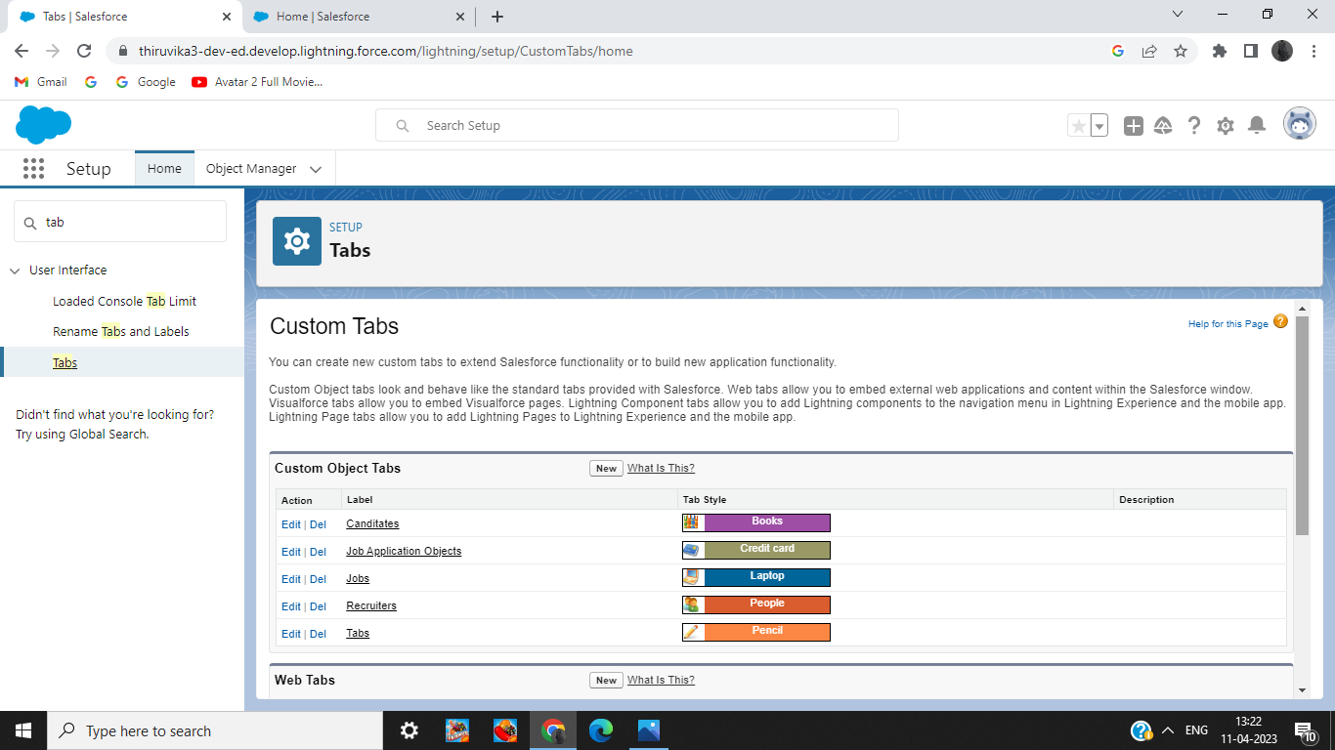

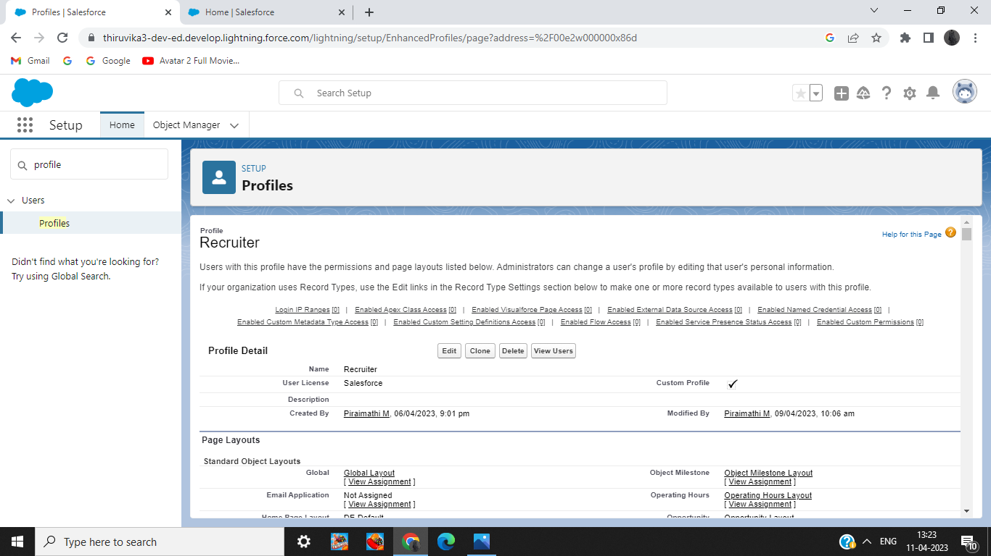

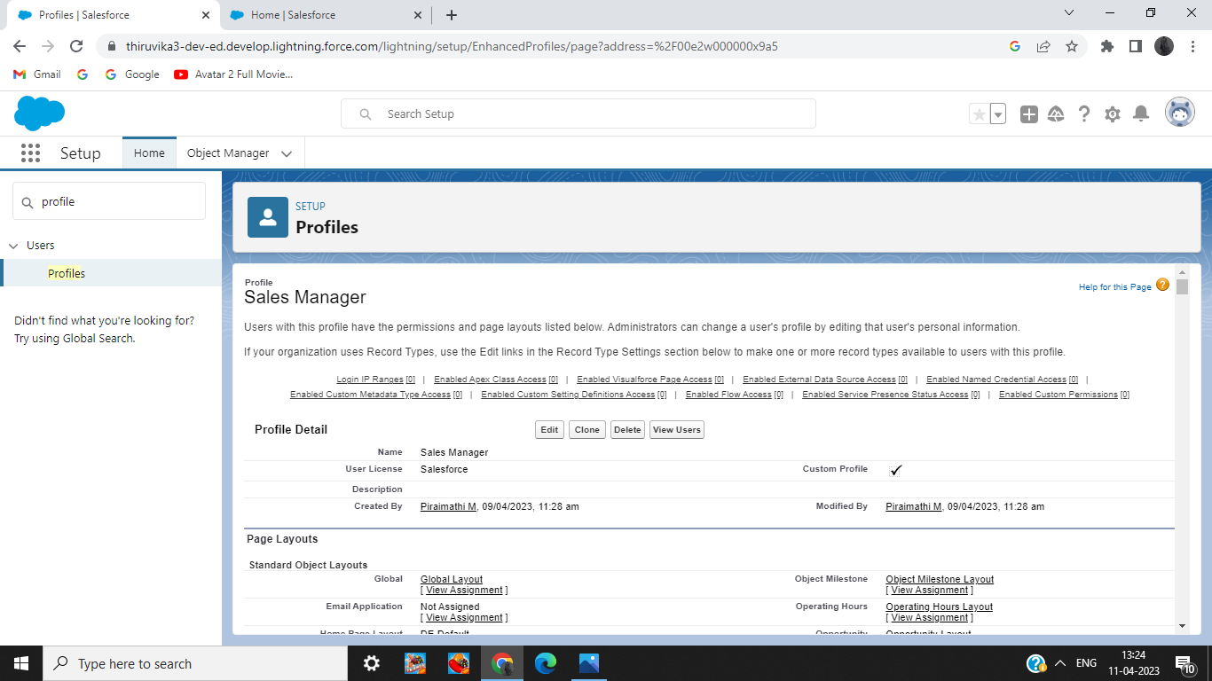

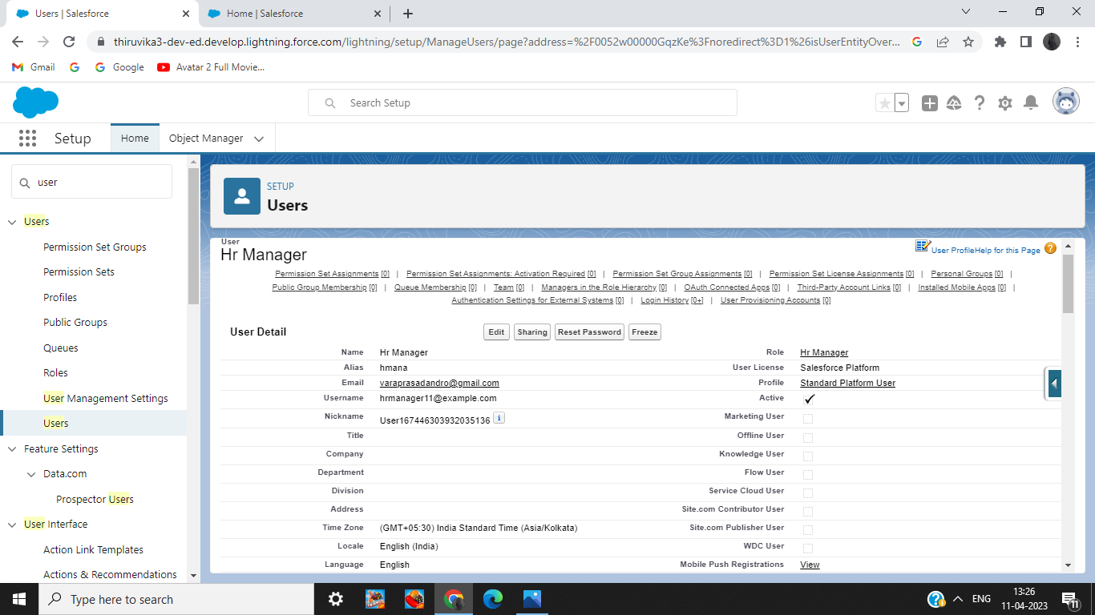

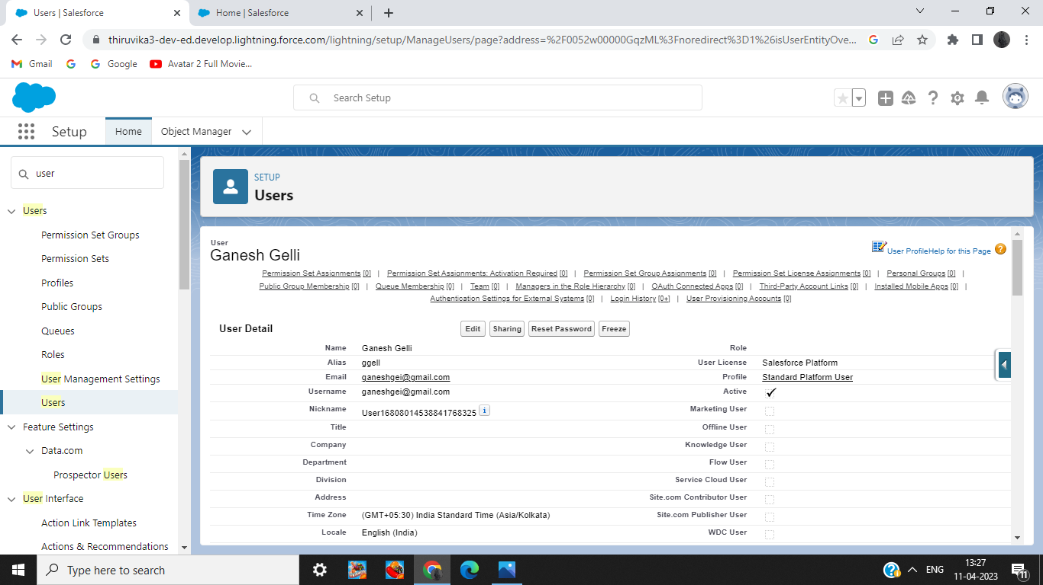

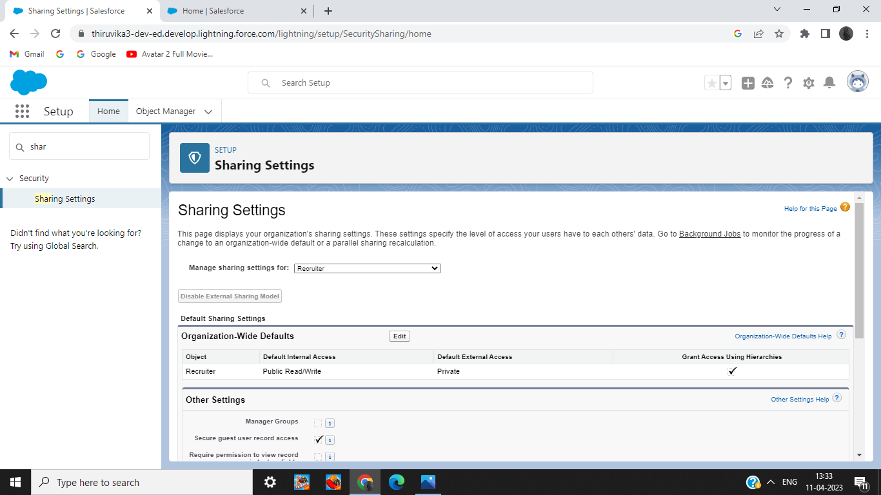

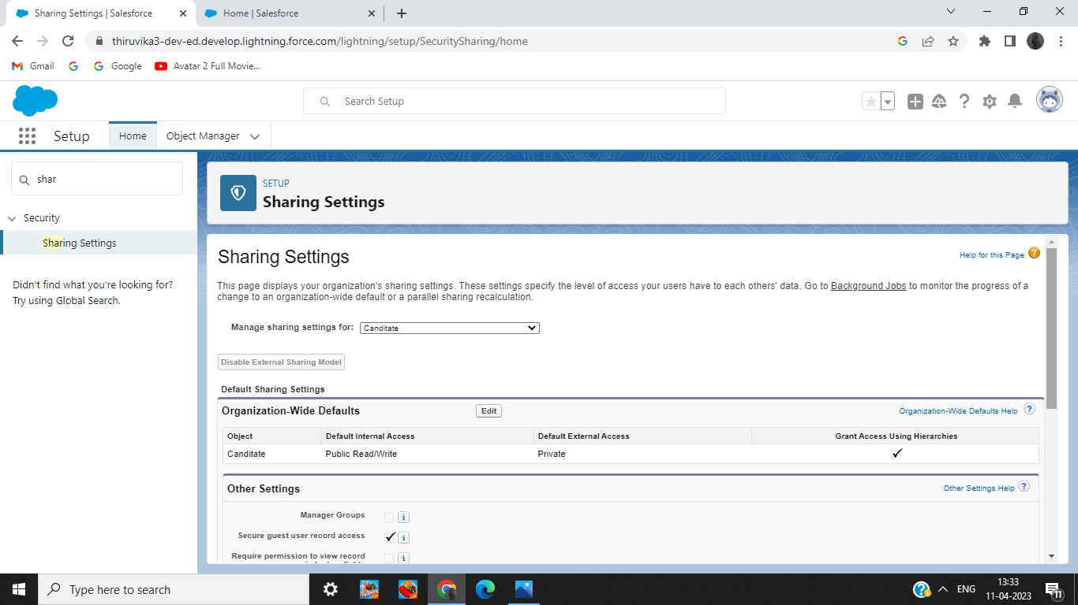

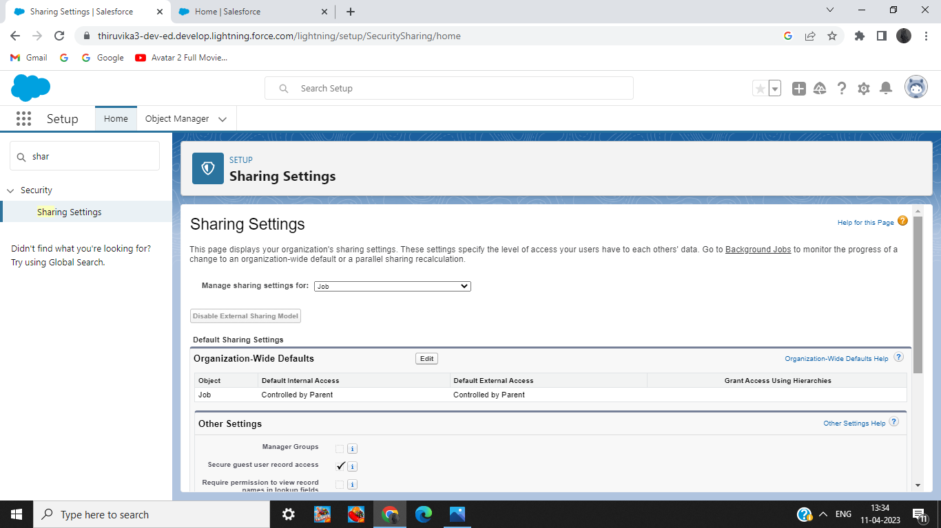

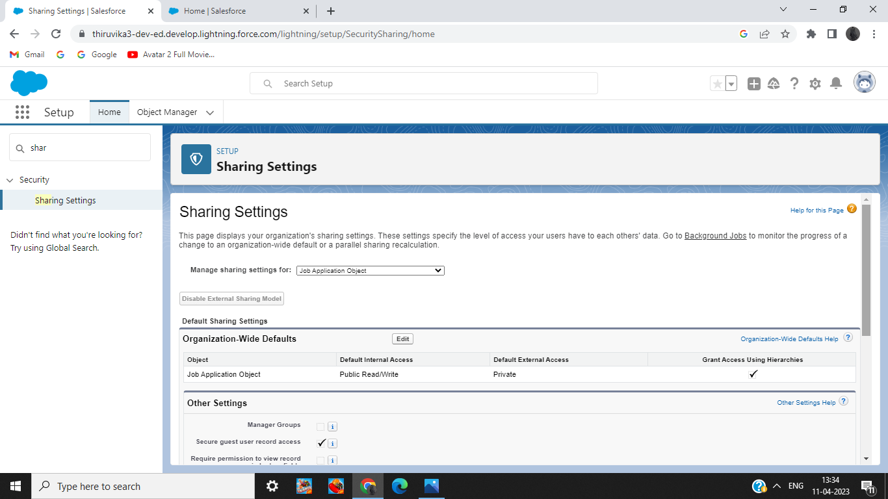

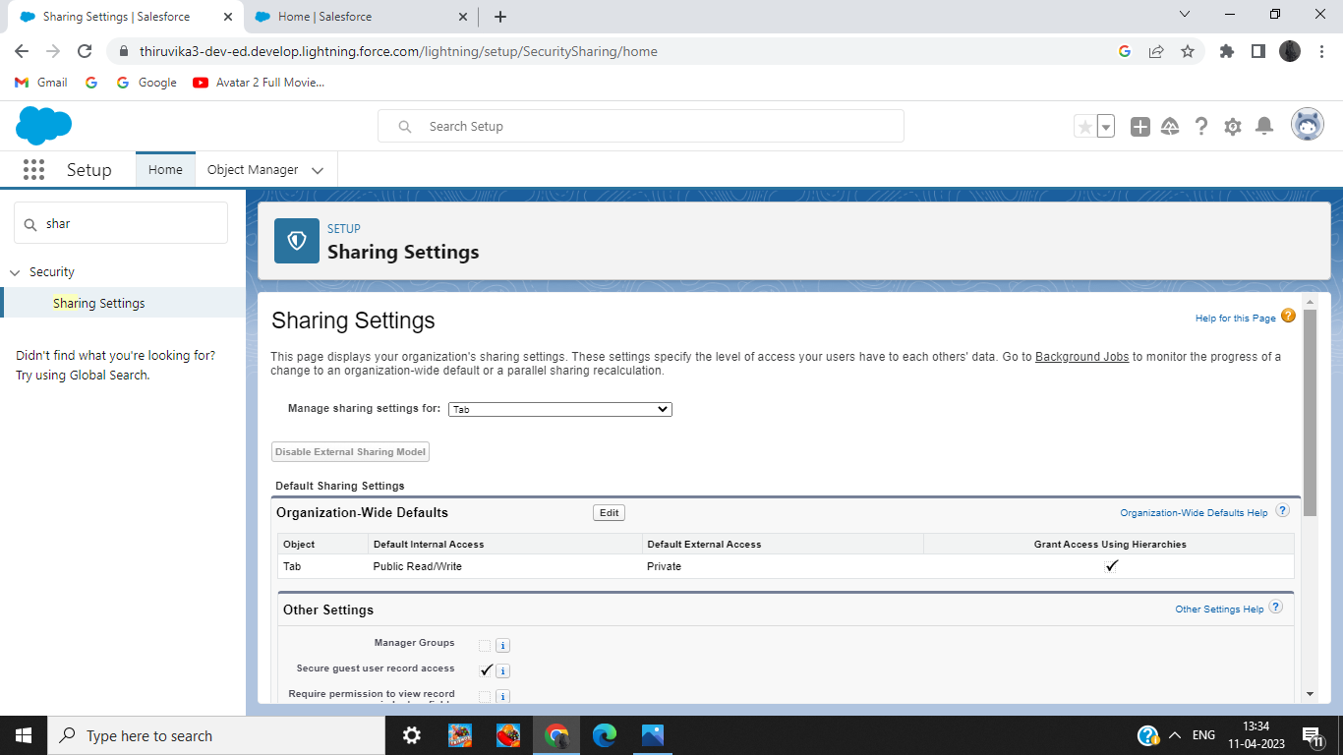

Reports

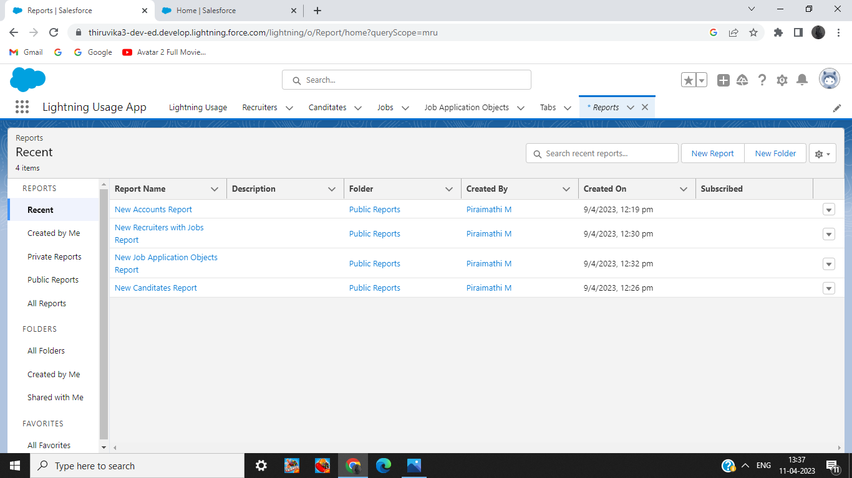

# 4.Trailhead Profile Public URL

Team Lead - trailblazer.me/Id/piram2

Team Member 1 – trailblazer.me/id/pprithivi

Team Member 2 – trailblazer.me/id/sabis18

Team Member 3 – trailblazer.me/id/sandm59

# 5.Advantages & Disadvantages

Advantage : It gives complete access to all applications , presenting them on the same front.

Disadvantage :Missing qualified applicants due to wrong keyword selection.

# 6.Applications

Job tracking system is something that can be done in the places where employment is sought.

# 7.Conclusion

We categorized its benefits and importance and we have done this project to the best of our ability.

# 8.Future Scope

There is no doubt that job tracking system will become an important part of future life as the number of job seekers increases day by day.